# Govorni in slikovni sistemi: Vaja 1

## Naloga 1:

|  |  |
| --- | --- |
| **glas** | **Moj posnetek** |
| o | 1.973– 2.097s |
| a | 2,974 – 3,130s |
| u | 3.859 – 3.892s |
| E | 4,441 – 4,566s |
| i | 4,884 – 5,010s |
| O | 5,252 – 5,400s |
| e | 6,255 – 6,320s |
| @ | 6,542 – 6,608s |

## Naloga 2:

1. **Frekvenca vzorčenja:** 16000Hz
2. **Dolžina posnetka v sekundah:** 8,229
3. **Podatkovni tip:** 32bit int
4. 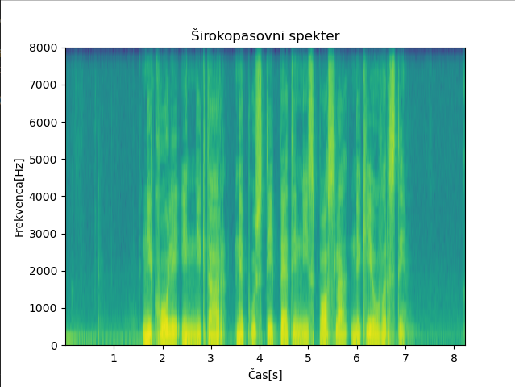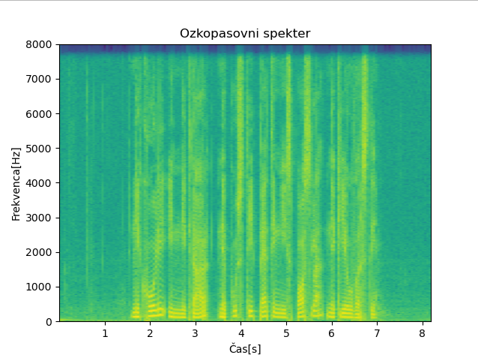**Zaloga vrednosti posnetka:** [-1491200000, 1366273920]

## Naloga 3:

|  |  |  |
| --- | --- | --- |
| **glas** | **F1** | **F2** |
| o | 300hz | 750hz |
| a | 625hz | 1450hz |
| u | 300hz | 900hz |
| E | 500hz | 2000hz |
| i | 220hz | 2500hz |
| O | 120hz | 600hz |
| e | 400hz | 2200hz |
| @ | 400hz | 1200hz |

